Using Crowdsourcing to Combat the Spread of the Emerald Ash Borer in Minnesota

By Caleb Mackey

Geography 579

12/6/2016

**Abstract**

The emerald ash borer (EAB), *Agrilus planipennis* Fairemaire (Coleoptra: Buprestidae), is an invasive species that has killed hundreds of millions of ash trees (*Fraxinus* spp.) in North America since it was discovered here in 2002. The best defense against slowing the spread in Minnesota may be early detection and quarantine (preventing the ash wood to be moved across county lines if not first treated to kill larvae inside). The Minnesota Department of Agriculture and DNR are working together to monitor EAB traps but early detection is a challenge. Therefore, in this study, a mobile GIS application is being developed for an effective early detection by allowing any person to take a photo and report an EAB sighting. By using the ArcGIS Runtime SDK for Qt, the application can be written once in QML/JavaScript and then easily ported to iOS, Android, and Windows devices to create a native, cross platform mobile application. Because the application will be available to anyone with a mobile device, more EAB sightings can be reported to a centralized database via crowdsourcing. Decision makers can then use the application to validate sightings and institute county quarantines in new infestation sites to prevent further spread. The application and its functionalities are very promising and has potentials of contributing to the early detection.

## **Introduction**

The emerald ash borer (EAB), *Agrilus planipennis* Fairemaire (Coleoptra: Buprestidae) is an invasive species that has killed hundreds of millions of ash trees (Fraxinus spp.) since it was first discovered in US and Canada in 2002, and is spreading rapidly in Minnesota. Because this pest is notoriously hard to track and predict where it will move due to unintentional human transportation through wood products, early detection of new infestations is a difficult task. Using web GIS to promote recording new sightings of EAB through crowdsourcing in Minnesota could prove to be an effective means for early detection. If this data is made available to decision makers, quarantines can quickly be put in place to prohibit ash wood from being moved outside of the county lines, which could ultimately slow the spread of the EAB in Minnesota.

### **Dispersal, Biology and Ash Trees**

The Emerald Ash Borer was first found in the US in the greater Detroit, MI area in 2002, but it had likely been here since the late 1990’s (Anulewicz et. al 2008, Poland and McCullough 2006). It is believed that they traveled from China in wood shipping pallets. Since its induction to the US, this invasive beetle has quickly spread across the Midwest and eastern US where the ash resource is the most plentiful (Figure 1). They have been able to thrive here due to the lack of natural predators and the abundance and vulnerability of ash trees in the Midwest. In their native range in Asia, ash trees have developed a resistance to the EAB and with the presence of natural predators, they do not cause much damage there (Rebek et al. 2008).

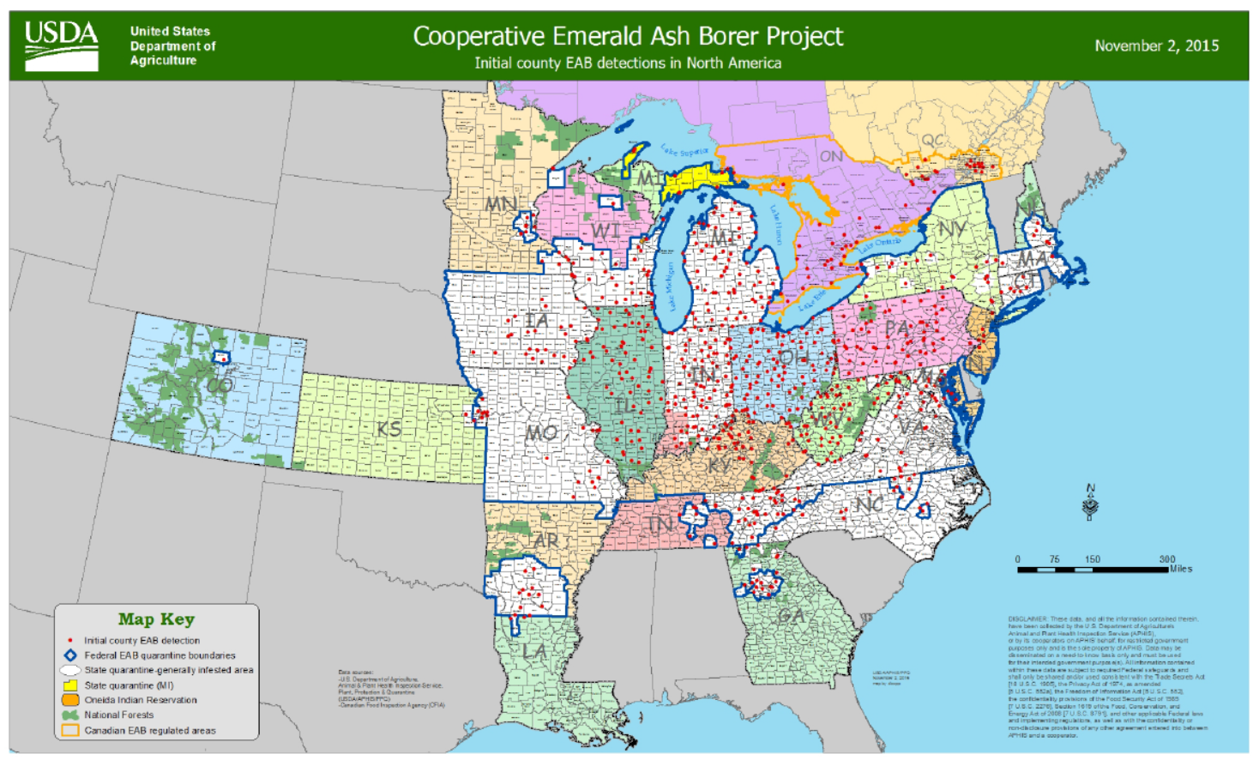 **Figure 1. Current EAB Distribution (USDA 2015)**

Ash are a very common tree found in forests and are especially abundant in urban settings in Michigan, Chicago, and New York comprising approximately 15-20% of all urban tree species (BenDor et al. 2006). Their spread has been notoriously difficult to track because the adults lay eggs on the bark of the tree, allowing the larvae to bore into the vascular tissue of the tree, where they will feed up to two years (Marshall et al. 2010). This kills the tree because the larval galleries disrupt the nutrient flow from the roots to the crown of the tree. Because the larvae live in the tree for so long, the infested wood is often transported long distances by humans.

Depending on the intensity of the infestation, EAB larvae can typically kill an Ash tree within 2-4 years. Populations tend to be strong in areas with dense Ash populations because they do not have any natural predators, they have been very effective in damaging Ash stands. In fact, they have nearly wiped out the entire Ash population in Michigan’s forests with estimated ash mortality at 99% (Klooster et al. 2013). They have also had significant impacts in urban areas. Damages in cities for removal/replanting of heavily infested and dying ash trees in Ohio communities is estimated in the billions (Syndor et al 2007).

### Discovery in Minnesota and Quarantine Efforts

The EAB was first discovered in the Saint Anthony’s Park area of St. Paul in 2009. Not long after, additional sites were found near Winona and Rochester (Minnesota Department of Agriculture). Since then it has spread to 11 different counties and does not appear to be slowing down. Quarantines are initiated in areas where there are known EAB infestations to require that the wood cannot be moved outside the county lines unless treated to kill larvae first. These are administered at the county level in Minnesota. Since there are no natural predators to the EAB in Minnesota, they have been able to establish strong populations in certain areas. In order to slow their spread, early detection is key to institute quarantines to prevent infested wood from spreading elsewhere.

### **Crowdsourcing and Mobile GIS**

Currently, the agencies (Department of Agriculture, Forest Service, and DNR) tracking the EAB in Minnesota send staff to check for the presence of adult beetles while they are most active between May and August. They also train normal citizens on how to spot the EAB, and have a web site where people can report sightings. The idea is to have more “boots on the ground” to help track new sightings of this pest. One low cost option for early detection could be to combine this idea of crowdsourcing with GIS. These two ideas can be merged through an “EAB Tracker” mobile GIS application where any user with a smart phone can report a sighting by taking a photo and logging some information about the sighting. Additional functionality will also be made available to the decision makers so they can view sighting reports and verify that the sightings are legitimate EAB beetles or if they are just look-alikes. If it is a real sighting, they can then use the application to change the county in which the sighting is located to under a quarantined status.

The mobile application can be built with one of three approaches: natively, web-based, or hybrid. Native applications are developed for a specific platform such as iOS, with the advantage being you can take full advantage of all the of the device’s functionality. Native apps also look and perform the best. The disadvantage is that the app can only be deployed to one platform and there is a steep learning curve as well as requiring a strong knowledge of the OS. The second approach is to create a web-based mobile application (HTML5) that works through a web browser. This approach is good because the app is cross-platform and can be used by any device that has a browser installed. The disadvantage with web-based applications is that there are many different devices out there with different screen sizes and creating good responsive design to the device becomes difficult and this requires a web server to host from. More importantly, you do not have access to all of the device functionality, such as the camera which is required for the EAB Tracker app. There is also limited access to much of the device functionality such as the camera or GPS capabilities. The third type is the hybrid approach. This type of app can also be deployed across all platforms and has greater access to device by using thin native wrappers around web applications by using frameworks such as PhoneGap and Cordova. The drawbacks here are that the user experience is not as good as a native app and like the web approach, this requires hosting the app from a web server (Korf and Oskman, 2015). Figure 2 shows the functionality matrix between the three development options.

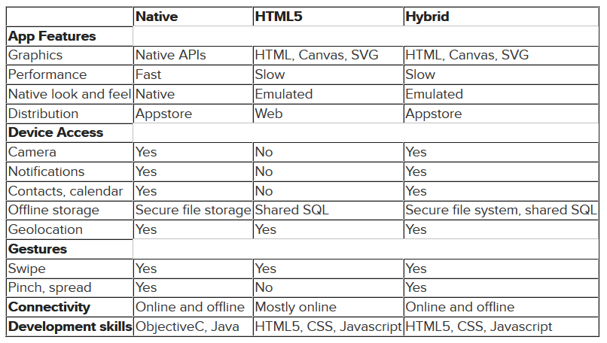**Figure 2. Functionality Matrix between the Three Mobile Application Development Scenarios (Korf and Oksman, 2015)**

Choosing the right development platform for this application is crucial and the requirements of the EAB Tracker app and the resources available to me were the driving factors for which platform I decided to use. Due to lack of a web server, the web and hybrid approaches were not an option; otherwise the hybrid approach would have been optimal for rapid development of a cross platform app. Because the app will be developed natively, the first problem here is that it needs to be available for iOS, Android, and Windows. After looking at the native Software Development Kits (SDKs) offered on the Esri platform, I discovered the ArcGIS Runtime SDK for Qt.

Qt (pronounced as “cute”) is a cross-platform native application development framework that can be used to build applications that often does not require any changes to the original code base when deploying to different platforms and exhibits native performance. By taking advantage of this SDK, I can write and design the application in one framework and deploy the app to iOS, Android, Windows. Qt is used for creating native application software with graphical user interfaces (GUI) and uses C++ extensions. GUI components are provided and the application logic can be coded in either C++ or Qt Modeling Language (QML), which is a declarative, JavaScript based language provided via Qt Quick. To use Qt, you have to install the Qt Creator Integrated Development Environment (IDE). This comes with the Qt Framework and allows the user to specify device emulators and qmake files. The qmake files are what are used to deploy the app to multiple platforms, and each platform requires its own set of development tools for the application deployment from Qt Creator.

In addition to the ArcGIS Runtime SDK for Qt, Esri also provides a program called AppStudio for ArcGIS, which is a tool that can be used to port apps developed with the Qt SDK to different platforms. The difference with AppStudio is that there are some pre-set templates that were designed specifically for mobile devices and there is also a “Cloud Make” option, where you can share the app to ArcGIS Online as a Native App, and the Cloud Make tool can port it to iOS, Android, and Windows through a service (Figure 3). The nice thing about this is you do not need to have the emulators and necessary software installed to port to all the different platforms. This is especially useful for my EAB Tracker application because I need to port it to iOS and if I were just using the Runtime SDK for Qt, I would need a Mac in order to do this and test on an iOS device emulator. With the decision being made on which platform to go with, I was able to start developing the application.

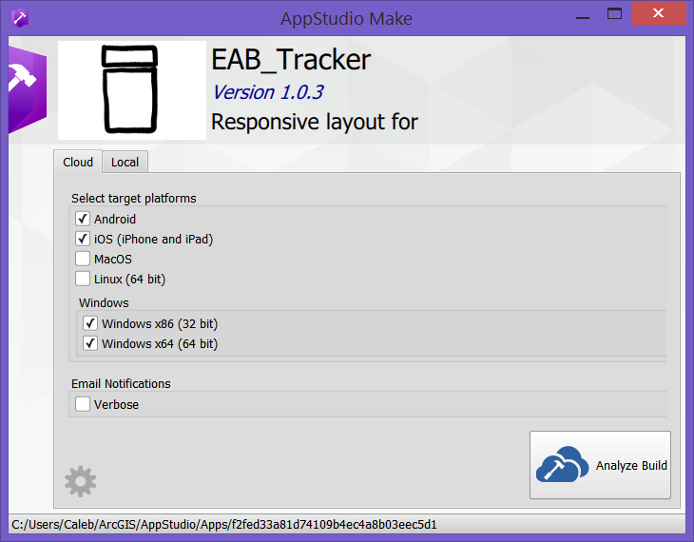**Figure 3. AppStudio for ArcGIS Cloud Make Tool**

## **Methods**

### Data Preparation

Since I do not have a web server of my own available to publish the necessary data for the mobile application, I needed to publish the data to ArcGIS Online. A file geodatabase was set up with a point feature class to track individual sightings and a polygon feature class to track counties with their quarantine respected status. The target user of this application is the average citizen who may not know much the EAB so the data schema needed to informative for decision makers and intuitive for the user. Attribute domains were created with helpful description aliases so that even users unfamiliar with the EAB can record detailed information about the sighting.

The attribute domains allow the user to describe the type of sighting such as adult beetle, visible larvae, D-shaped exit holes, and S-shaped galleries. Another field tracks information about any visible tree stress such as crown dieback, epicormics shoots, and bark splitting. For purposes of checking data integrity and reliability of the user, another field was added to get a sense of the user’s knowledge level of the EAB with options such as that user being a biologist or entomologist, environmental scientist or similar, or not having much knowledge of the beetle. Other fields that user could fill in were site descriptions, comments, and their name and email. Other attributes are automatically populated by logic built into the application to report the latitude and longitude as well as an address provided by reverse geocoding the input point.

The county polygons were much simpler with the only important attribute other than the county name being the current quarantine status. There are three options for the application: currently quarantined, no positive sightings, and needs to be considered for quarantine. The sighting points and county data was published to ArcGIS Online as a hosted Feature Service with editing capabilities and shared as a public service.

### **Application Development**

The mobile application prototype was developed using the ArcGIS Runtime SDK for Qt. QML was chosen as the programming language to use for the application logic because I already had experience in JavaScript development. The application has several requirements:

* *Geolocation to allow user to report sighting at their current location*
* *Allow the user to use their device camera to upload photos of sightings as attachments (1 or more photos)*
* *Feature identification so decision makers can view sighting reports in app*
* *Elevated privileges for decision makers under an extra blanket of security. They can log in and perform feature edits to change county quarantine status.*

The ArcGIS Runtime SDK has support for many common GIS operations and supports many types of data layers. All data layers must come from a web service and there is functionality within the SDK to create replica file geodatabases for offline editing as well. All data for this application is referenced from the MNSU ArcGIS Organizational Account on ArcGIS Online (AGOL) and from the MN Department of Agriculture’s ArcGIS Server Site.

Different functionality was included to grab the user’s current location using the devices GPS. The application loads at the extent of the state of Minnesota using the “Esri World Street Map” as a basemap and tries to enable Geolocation if there is service available (Figure 4). User Interface (UI) button components were added to trigger certain events such as report a sighting and enable/disable identify.

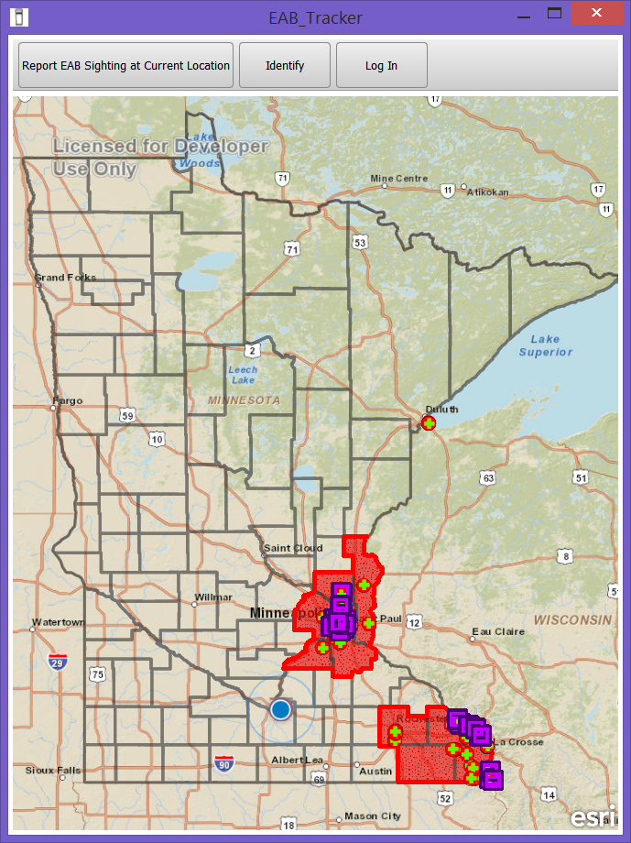**Figure 4. Initial View of the Application with Geolocation Enabled**

When the user hits the “Report Sighting at Current Location” button, this triggers several events in the application. First, a point is added to the “Sightings” feature service at the user’s current location. If there are not location services available or the user refuses to share their location with the app, a warning message will appear and let them know that they have to manually place a point on the map at their location before they can report the sighting. Once the point has been logged, an attribute form pops up to collect information about the sighting that is populated with the domains to help the user describe the sighting. There are three buttons at the bottom of the form to “Add a Photo”, “Send Report” and “Cancel”. Because photo evidence is required with each sighting, the “Send Report” button is disabled until the user takes at least one photo from their device (Figure 5). Once the photo is added, the attachment(s) are applied to the feature service and upon a successful signal indicating the attachments were added, the point feature is then edited with the attributes from the form the user filled out.

When a sighting has been successfully reported, another event is triggered to check the county data. The counties layer in the Feature Service is queried using the “findFeatures()” method to select the county that intersects the point that was just collected. If the selected county’s quarantine status is “No EAB Finds Yet”, this status is automatically changed to “Needs to be considered for quarantine” and the county symbology changes from hollow to orange (Figure 6), indicating that it needs to be checked by a decision maker from one of the agencies monitoring the EAB.

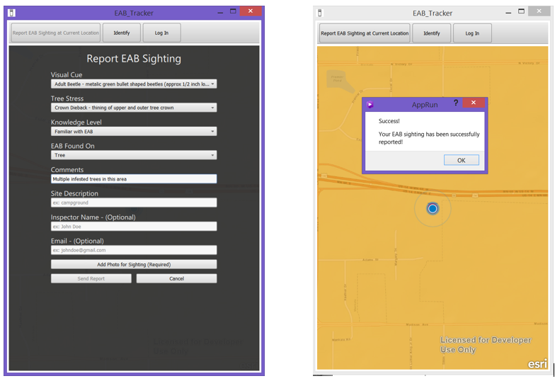**Figures 5 (Left) and 6 (Right) show the form for the sighting collection information. Once a point has been logged, the user gets a message that it has been successfully recorded and the county is highlighted in orange to signify that it needs to be reviewed for possible quarantine status.**

A “Login” button was also included for the so that decision makers can login to make changes to a county’s quarantine status. Once a user has logged in using the proper credentials, an extra “Edit” button appears. When the user has successfully logged in, an edit session initialized for the counties layer. The idea is that the user can click on any sighting point to view the attributes and photo of the sighting (Figure 7). If the user can verify that the sighting is indeed an EAB and not a look-alike, they can then log in and change the quarantine status of a county by clicking on it (Figure 9). If the user decides to place the county under quarantine status, it then gets a red fill to show that ash wood can no longer be moved outside the county lines (Figure 10).

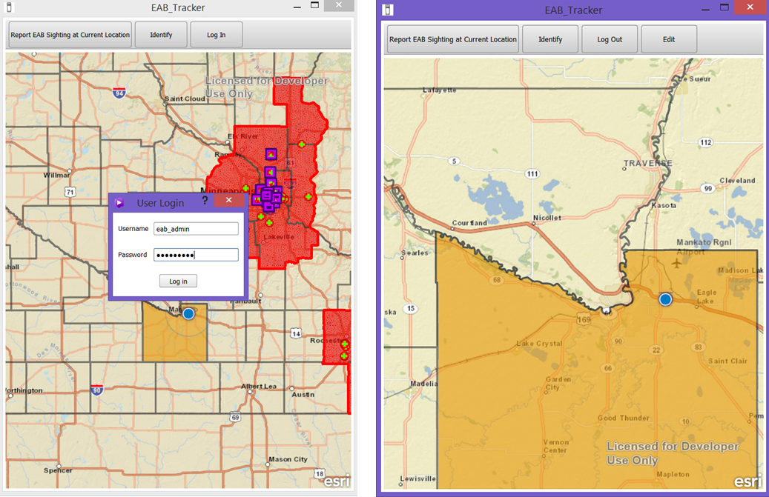**Figure 7. Once the user logs in, they get an extra “Edit” button to allow them to start an editing session on the counties layer.**

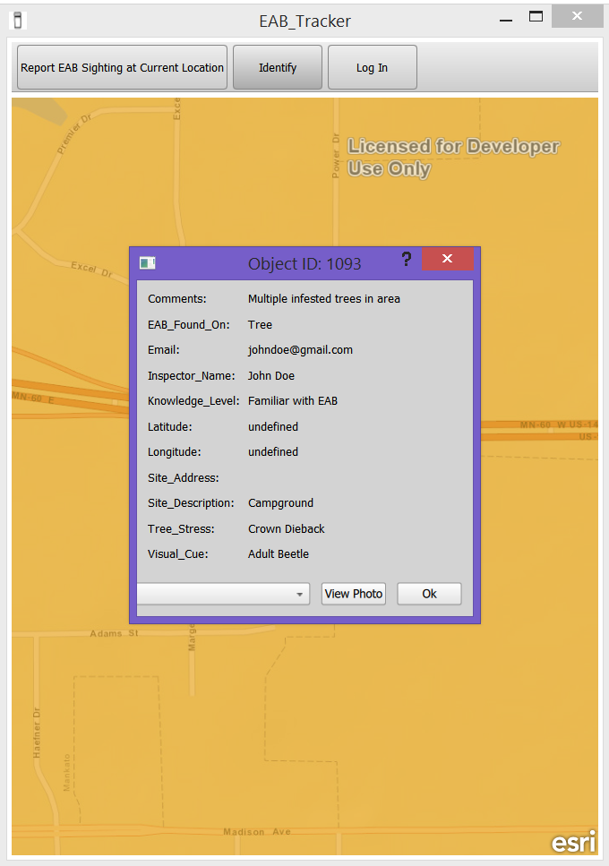

**Figure 8. When the user clicks on a sighting point, they are able to see the attributes collected. At the bottom there is a list of attached photos as a drop down list (still under development). Once the user highlights a photo in the drop down, they can hit the “View Photo” button to see the evidence of the sighting.**

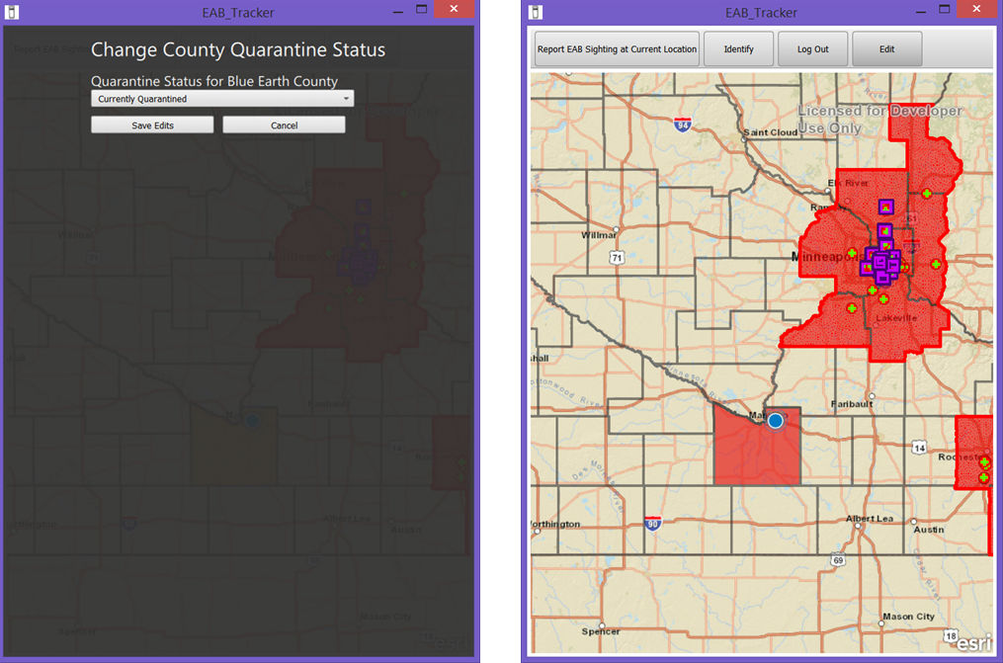

**Figure 9. When an administrator is in an edit session and clicks on a county, the dialog on the left pops up to allow the user to change the quarantine status. If they change it to “Currently Quarantined”, this pushes an edit back to the feature service and changes the county’s symobolgy to a red fill.**

# **Expected Results**

So far, the app is still in beta mode and has only been tested on Windows and an iPad. There are still several bugs that need to be worked out and additional functionality added before the app will be ported to the app stores and available for download. However, I believe that when this application is finished, it will prove to be very beneficial for tracking new EAB sightings in Minnesota. That being said, there are also some big challenges ahead.

The application will need to be fully developed and tested on the iOS, Android, and Windows platforms prior to May when the adult EAB beetles are most active. Not only does the app need to be working and fully functional, it needs to be made aware to people that this application is available for reporting EAB sightings in Minnesota. I will need to use social media and also reach out to biology departments at universities across Minnesota to find people who are willing to download the app and “keep an eye out” for EAB in their area. I will also need to get the support of the agencies who are monitoring the beetle so they can advertise this application to citizens who attend their training sessions on how to spot the EAB.

I believe if enough people are aware of this app and of the EAB problem in Minnesota, I think that a few more counties could get quarantined as a result and I would call that a success for early detection. I hope that people are using the app between the months of May and August when this beetle is most active so I can track how many people are downloading using it. I am also curious to see the variety of knowledge levels of people who are reporting sightings. I expect this list to be comprised of mostly biologists as they are more likely to be proactive with this issue and use the application to report sightings than the average citizen.

# **Conclusion**

As the Emerald Ash Borer continues to spread in Minnesota, I hope that my application can help to slow its spread a little bit. I still have a long ways to go for the application development and with getting the word out about this app being made available this spring. I am hoping to wrap the development of the initial release of this app over winter break and get it pushed to the app stores for iOS and Android. I believe if enough people are using the app, it will make a difference in Minnesota to slow down the spread of the emerald ash borer if quarantines are set quickly after new sightings are reported.

# **References**

Anulewicz, A. C., Mccullough, D. G., Cappaert, D. L., & Poland, T. M. (2008). Host Range of the Emerald Ash Borer ( Agrilus planipennis Fairmaire ) ( Coleoptera : Buprestidae ). *Environmental Etomology*, *37*(1):230–241.

BenDor, T. K., Metcalf, S. S., Fontenot, L. E., Sangunett, B., & Hannon, B. (2006). Modeling the spread of the Emerald Ash Borer. *Ecological Modelling*, *197*(1-2):221–236. doi:10.1016/j.ecolmodel.2006.03.003.

Klooster, W. S., Herms, D. a., Knight, K. S., Herms, C. P., McCullough, D. G., Smith, A., … Cardina, J. (2013). Ash (Fraxinus spp.) mortality, regeneration, and seed bank dynamics in mixed hardwood forests following invasion by emerald ash borer (Agrilus planipennis). *Biological Invasions*, *16*(4):859–873. doi:10.1007/s10530-013-0543-7.

Korf, M.,& Oksman, E. (2015). *Native, HTML5, or Hybrid: Understanding Your Mobile Application Development Options*. Retrieved from <https://developer.salesforce.com>.

Marshall, J. M., Storer, a. J., Fraser, I., & Mastro, V. C. (2010). Efficacy of trap and lure types for detection of Agrilus planipennis (Col., Buprestidae) at low density. *Journal of Applied Entomology*, *134*(4):296–302. doi:10.1111/j.1439-0418.2009.01455.x.

McCullough, D. G. M. C., Poland, T. M., Anulewicz, A. C., & Cappaert, D. (2009). Emerald Ash Borer ( Coleoptera : Buprestidae ) Attraction to Stressed or Baited Ash Trees. *Environmental Entomology*, *38*(6):1668–1679.

McCullough, D. G., & Mercader, R. J. (2012). Evaluation of potential strategies to SLow Ash Mortality (SLAM) caused by emerald ash borer ( Agrilus planipennis ): SLAM in an urban forest. *International Journal of Pest Management*, *58*(1):9–23. doi:10.1080/09670874.2011.637138.

Poland, T. M., & McCullough, D. G. (2006). Emerald ash borer: Invasion of the urban forest and the threat to North America’s ash resource. *Journal of Forestry*, *104*(3):118–124. Retrieved from <Go to ISI>://000237540400003.

Rebek, E. J., Herms, D. a, & Smitley, D. R. (2008). Interspecific variation in resistance to emerald ash borer (Coleoptera: Buprestidae) among North American and Asian ash (Fraxinus spp.). *Environmental Entomology*, *37*(1):242–6. Retrieved from http://www.ncbi.nlm.nih.gov/pubmed/18348816.

Sydnor, T. D., Bumgardner, M., & Todd, A. (2007). The Potential Economic Impacts of Emerald Ash Borer ( Agrilus planipennis ) on Ohio , U.S ., Communities. *Agriculture & Urban Forestry*, *33*(1):48–54.